Exercise no:8

Date:21.11.20

Aim:

To write a Python program to get a list, sorted in increasing order by the last element in each tuple.

Program:

lst=[]

list1=int(input("enter no. of elements:"))

for x in range(0,list1):

val=int(input())

lst.append((val,pow(val,3)))

lst1=sorted(lst)

print(lst)

print(lst1)

Link:

<http://103.53.53.18/mod/vpl/forms/edit.php?id=317&userid=1702>

Output:

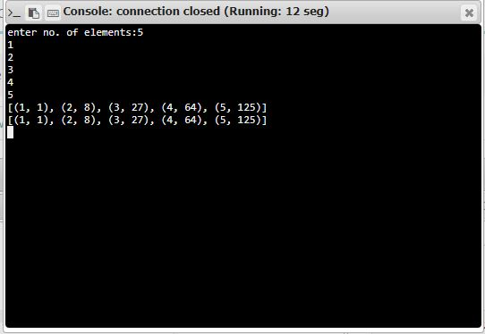

Result:

Thus the program has been successfully executed and the output is verified.